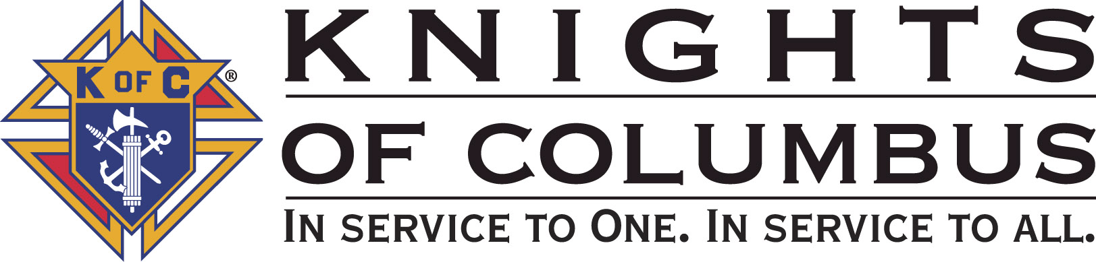

Council #13672 at Divine Savior Fr. Neil W. Seidl
Orangevale, CA
March 2010 Volume 8, #2

Monthly Grand Knight’s Message
Grand Knight Charlie McDermott

Dep. Grand Knight Bruce Pyle

Fin. Secretary Micheal Wagner

Treasurer Allen Brown

Chancellor Tom Hogan

Warden Bob Reilly

Advocate Dave Brodie

Recorder Ray Coughlin

Trustee 1st Year Bill Windle (PGK)

Trustee 2nd Year Mike Duskus (PGK)

Trustee 3rd Year Joe Luchi (PGK)

Inside Guard Steve Mann

Outside Guard Douglas Copley

Chaplin Fr. Roman Mueller

Lecturer Tom Lawson

Field Agent Tony Magdaleno

The Knights of Columbus Council #13672 at Divine Savior Fr. Neil W. Seidl Chapter meets Monthly on the First Tuesday of each month at 7:00 p.m.
Please join us to help our Catholic Community.
For insurance needs, please contact our Field Agent Tony Magdaleno at 470-9205 or by mail at
P.O. Box 2737
Rancho Cordova, CA 95741
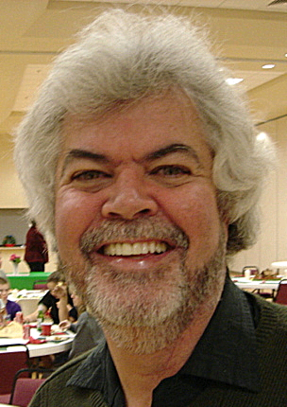
Greetings Brother Knights:

I want to first thank our Deputy Grand Knight Bruce Pyle for filling in for me last month. I appreciate you leading our Council through all the activities and events that were on the agenda! It is also wonderful to welcome back our worthy Treasurer Mike Wagner from his recent surgery. It is nice to see you/him on the mend and on the road to a full recovery! And a big thank you to Don Rose for filling in for Mike in his absence.

So now we are back at full officer staff and moving forward. Tonight we will hear about the following:

- Events and activities over the next few months from our Service Program Managers.
- Membership – We are making very good headway, but we still need everyone’s help in crossing the finish line.
- Review and update our insurance from our insurance needs.
- Finally, March brings not only the beginning of spring, but also serves as a reminder that Council elections are just around the corner. Over the next few months, we will hear from our Council Officers on their responsibilities. I encourage all members of the Council to consider serving as an officer during the next Columbian Year. If you have any questions or are interested in a particular Officer position, please contact the Council’s Election Committee Chairman, Bob Reilly (988-1040).

More events are on the horizon, so let us continue our journey of service; let us continue to make a difference!
God Bless us all.

Charlie McDermott,
Grand Knight

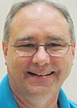
Treasurer Report
(As presented by Allen Brown)

KOC Council No. 132672 – Date balanced: 3/2/2010

Checkbook & CD Balances:
Business: $8,989.20
CD50 - 52: $3,223.48
Charity: $1,414.40
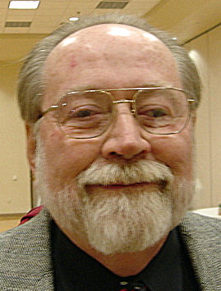
Total: $13,627.08

Financial Secretary’s Corner
(As presented by Don Rose for Michael Wagner)


February Receipts
No receipts were read at the March meeting. February and March receipts will be reported at the April meeting.

Knight of the Month
(Presented by Charlie McDermott)

- Dennis Harrington

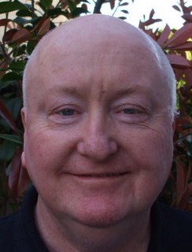
If the Knights of Columbus had an officer position entitled Information Officer, this brother Knight would exemplify the perfect choice to fill that position. He has worked diligently behind the scenes to help me develop our Council Gmail account and mentor me on its use. He has been working quietly in the background to create our Council website- the site is currently in development and we should see it role out in the next few months. Finally, he has taken our Council’s newsletter to the next level and has received rave reviews for his work in adding pictures of our Council Officers, Service Program Directors, Knight & Family of the Month Recipients and New Knights that join our Council.
What’s interesting is that he took on that assignment with less than 4 months experience within the Knights of Columbus. He also took on the assignment with very little knowledge of Microsoft Word application. What he brought to our Council was a willingness to get involved; willingness to learn and a desire make things happen. Please join me in congratulating Dennis Harrington as our “Knight of the Month”

Families of the Month

(As presented by Charlie McDermott)

- Families of the Month - ANDY AND JOAN VENTIMIGLIA
DAVE AND ELLIE BRODIE

Our worth Chancellor Tom Hogan with the support of our Council Officers wishes to recognize both of these families for the work they do in co-leading a key event throughout our Columbian year. So let me talk a bit about them:

The first Knight and his wife are dedicated workers for Divine Savior Parish, our Council, and are instrumental in the success of our blood drives that are held at least three times a year and that he co chairs. He is a 3rd degree Knight and has been a member for 15 years. He has worked diligently on the following projects: Treasure Fest, Retainer Wall, October Fest, Tootsie Roll Drive for those with Intellectual Disabilities and Liturgical decorating of the church. In addition, he ushers at Mass. When there is work to be done, she is right by his side. She is involved in Liturgical church decorating, parish committees and is chairperson of the Meeter Greeters.

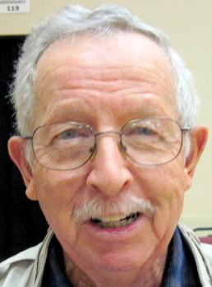
Our second Knight and his wife represent the type of leadership that sustains a good parish and council. He is a fourth degree Knight and past Grand Knight. In fact, he was instrumental in the establishment of our council. He is co-chairperson of our blood drives and has participated in the following activities: Hoe Down, Retainer Wall, October Fest, Treasure Fest and was chairperson of Tootsie Roll Drive for those with Intellectual Disabilities. In addition, both they are both Lay Eucharistic Ministers and also assist in the Homebound Ministry by serving communion. Indeed, our council and parish has been enriched through their humane acts. Please join me in congratulating our “Co- Family of the Month” ANDY AND JOAN VENTIMIGLIA and DAVE AND ELLIE BRODIE.

New Knights:
(As presented by Charlie McDermott)

No new Knights at this meeting.

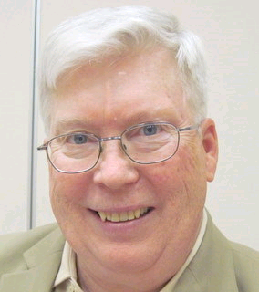
Recorder’s Motions
(As presented by Ray Coughlin)

Motions at March Meeting

The following motions were read and approved at the March Meeting:

- Donate $2,000.00 to Divine Savior parish building fund based on the proceeds from the January Spaghetti dinner. Funds are charity account, unbudgeted item.
- Donate $100.00 to 40 Days of Life Campaign. Funds are charity account, budgeted item.
- Transfer $2,200.00 form the business account to the charity account to cover charity donations. Funds are business account.
- Reimburse Tom Hogan $5.00 for Sunshine Committee expenses. Funds are business account, unbudgeted item.
- Advance Joe Rapier $250.00 for food and supplies for the March 21st pancake breakfast. Funds are business account, budgeted item.

The following motions were read and approved at the March Meeting:
Advance Mike Duskus, Bill Wagner and/or Mather Golf Course up to $8,000.00 for expenses relating to the golf tournament. Funds are business, budgeted item at $5,600

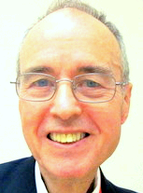

District Deputy News
(As presented by Gene Rexford, Warden
District #6 for Eldon Hancock, District Deputy)

The CA State Council in membership recruiting competition with Orange County Chapter for the month of February in a Special Contest recently initiated the Northern California Chapter. We are not sure at this point whether we won, but win or lose we are now in competition with another Chapter. By the way, how many of you are aware of the contest? Each Council is asked to recruit and exemplify new members as fast as possible over the next two months. If you are near Star, go for double star Star! One more thing. Should you get a Supreme Prospect Referral pursue it right away! Don’t wait until the next information night, or recruiting weekend.
Founders Day is coming March 29th. Supreme has requested that 1st Degree Exemplications have Fr. McGivny as the Honoree. This is also the 125th Anniversary of the Knights of Columbus.
State-wise, we are second to Texas! We could be first if all Councils really go for it. We are not that far apart. So…the question is…do we wish to remain “Superior” Northern California Chapter or just to be call the Northern California Chapter? Our next Chapter meeting will be hosted by St. Clare Council in Roseville on March 20th.
We are asking that each Council have as many members of their Council attend this meeting as possible. There will be two special speakers during the lunch hour. Father Kelley from the Sacramento Diocese, will talk about vocations…As you know, vocations are the prime concern by all dioceses in the USA…We need more priest, permanent deacons, brothers and nuns.
The next speaker will be Larry Franco, Manager from Arco Area for the Kings. He is a friend of the Knights and he wants to have a Knight of Columbus Family Nights at on of the King’s Games in early April. The Chapter President, John Norwood, will be meeting with him next week to firm up the cost and plans. To be continued, as there are many details to be resolved prior to the full publication.
The Chapter Free Throw last Saturday went very well. I don’t know if you had any winners, but I suspect that you may already have that information. Lastly, the Chapter thanks you for your contribution to the ultrasound machine. We are around $9500 towards our goal of $12,500.

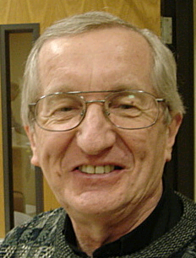
Reflections from the Chaplain
(Fr. Roman Mueller, SDS)

No reflections for this meeting

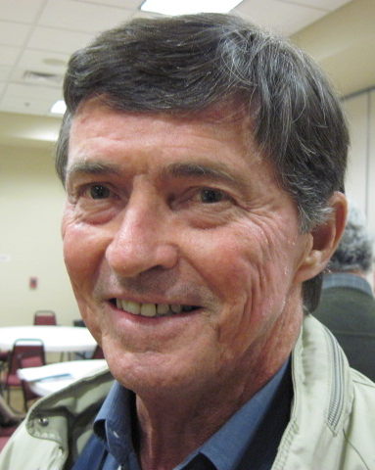

Let the Sunshine
(As presented by Tom Hogan)

Cards were sent out to Mike Wagner, Linda Aiello, Margaret Quigley For future need, please remember to contact Tom Hogan with any sunshine activity or prayer cards that need to be sent.

You can contact Tom at 916-988-2184 or 1mosel@comcast.net.

Remember that we really don’t know how far a little kindness will go.

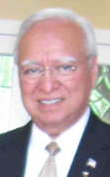
District Insurance News
(As presented by Tony Magdaleno)


KNIGHTS OF COLUMBUS INSURANCE
Making a difference for life

“TAX DAY IS JUST AROUND THE CORNER”

April 15 - tax day - is right around the corner. It’s become popular this time of year to encourage the opening of an IRA, ROTH-IRA or similar retirement annuity, or the depositing of additional funds into an existing account, as a tax savings vehicle. A secondary approach is to tout the rate of interest that money in one of these accounts can earn. Let me join the chorus, but for a different reason.

Certainly, contributing money to Knights of Columbus IRA annuity will allow you to save some money on your income tax return. And our annuities do pay a very competitive interest rate, consistent with our primary goal of absolute safety of principal. Opening or adding to an annuity for these reasons, however, strikes me as taking a short-term view of a product that is designed to provide long-term security.

Here at the Knights of Columbus, you can open a retirement annuity for as little as $300. Consistent and disciplined savings placed into that annuity over time can guarantee you an income at retirement that you cannot outlive. That guarantee – along with the fact that no one has ever lost money left in a Knights of Columbus annuity (absolute safety of principal), really will provide you with peace of mind.

Let’s meet for an explanation of the benefits of opening a Knights of Columbus IRA, ROTH-IRA of tax differed annuity. Also learn about our top-rated Life Insurance and Long Term Care Insurance plans.

As you ponder all the things that may not work out as you proceed toward retirement, think about one thing you can do to help yourself – opening a Knights of Columbus annuity. It’s reasonably priced ($300 to start), guaranteed, and controlled by someone you trust – you!

Contact me at (916) 470-9205 or e-mail me at tony.magdaleno@kofc.org

God bless you all.

Fraternally, Your Brother and Field Agent,

Tony Magdaleno (916) 470-9205
FA 14661
CA Lic. #OG27147
P.S. NEW MEMBERS, ASK ABOUT OUR NEW MEMBER ANNUITY PLAN!!!

Committee Report - Membership
(As presented by Ray Coughlin)

We are still in need of approximately 6 New Members by April- WE NEED EVERYONE’S HELP! The next second and third degree exemplification is March 6th in Carmichael. The membership team will be contacting all first degree Knights soon to schedule their exemplification.

Our membership tally is now at 125 members. If you know of someone who would like to join our council, please refer them to Ray Coughlin at (916) 989-

4226 or Tony Magdaleno at (916) 470-9205.

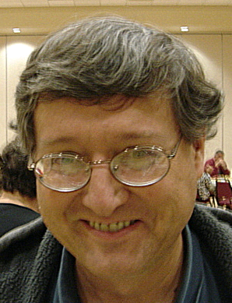
Committee Report - Youth
(As presented by Bill Manos)

Bill Manos reported that our council placed well in the free throw competition having 3 competitors advance to the third level. We fell short of state, but made a great showing and better than last year. After several weeks of

publicity and announcements, no scholarship applications were received. The council will probably reserve the money we had earmarked for scholarships until next year.
Please contact
Bill Manos at 965-3834 with any Youth Service Program questions.

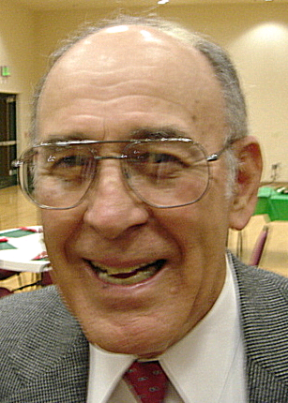

Committee Report - Family
(As presented by Guy Sanchez)

Guy Sanchez announced that plans are being made for a council Spring Social event. This will most likely be a River Cats game on May 7. Details to follow.

Please contact Guy Sanchez at 965-3834 with any Family Service Program questions.

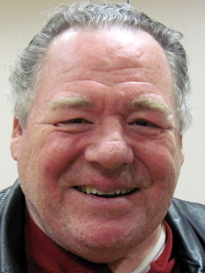

Committee Report – Council
(As presented by Bill Windle)

Former Council Director, Kelvin Joiner dropped by to thank the council for our friendship and to announce that he would be departing for the mid-west in the near future. He received our thanks, and best wishes on his journey.
Our next Pancake Breakfast will be held March 21. Contact chairman Joe Rapier to assist.
Our next blood drive will be May 16. Contact Andy Ventimiglia to sign up.
We have a Recycle Day planned for April 24. Details will follow after the appointment of a chairman by Bill Windle.
Tom Hogan, the new Sunshine Committee chairman, reported that all appropriate cards and wishes have been conveyed.
Since Council Elections are nearing, Bob Reilly will be heading the nominations committed with the assistance of Dave Brodie. Anyone interested in holding office during the next Columbian Year should contact one of those two for information and to put your name up for consideration. We’ll also be speaking about the roles of the officers during our next regular meetings.
The annual State Convention will be May 20-23 in San Jose. Our council needs two delegates and two alternates. If interested, contact Charlie or Bruce.

Please contact Bill Windle at 988-2239 with any Council Service Program questions.

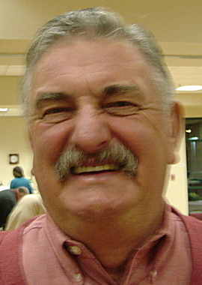

Committee Report – Church
(As presented by Dan Freeman)

Bob Reilly and Bruce Pyle shared the duties for Dan Freeman who was under the weather.
Our next council Corporate Communion will be March 14, at the 11:30 mass.
The semi-annual Strategic Plan Review took place on Feb 6.
Dan is soliciting volunteers to help the Parish Environmental Committee in preparing the church for Easter. Decorating/set-up work will take place on April 3. Contact Dan.
Bill Manos will coordinate our involvement in the Stations of the Cross on Good Friday, April 2nd.

Please contact Dan Freeman at 987-0908 with any Church Service Program questions

.

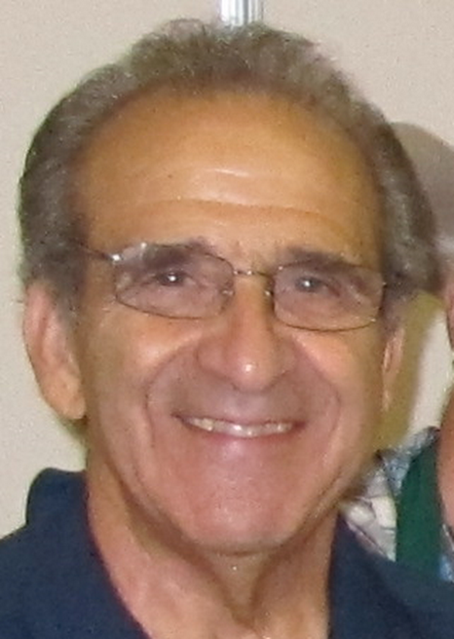
Committee Report - Community
(As presented by Tony Aiello)

Tony Aiello and Mike Duskus discussed our plans for the Golf Tournament we will sponsor on May 21. This could be our largest fund-raiser of the year. We need brothers to attend, either as golfers or as helpers. Contact Mike or Tony to join in an event, which could be as lucrative as it will be fun.
Pro-Life events were summarized. Mike Schaefer presented a full report of these important activities. And we organized a pro-life mass and prayer event for March 5th. Another vigil may be set for about a week later. Watch for Mike’s email.
Bruce talked about our proposed Fireworks Booth, planned for the week leading up to Fourth of July. Signups are needed to sell, for daily set-up and teardown, and for night security. This could be our largest fund-raiser of the year. Watch for Bruce’s email.

Please contact Tony Aiello at 987-0908 with any Community/Pro-life Service Program questions

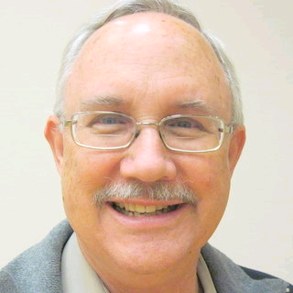
Future Council Planning Report
(As presented by Bruce Pyle)

Please remember to take photos at our events. We can share them at our after meeting social hour and we need them for our annual award reports.

Chairmen/director please include all hours (including planning and pre-event hours) in those annual award reports so we have a clear picture of the resources required to present our events.

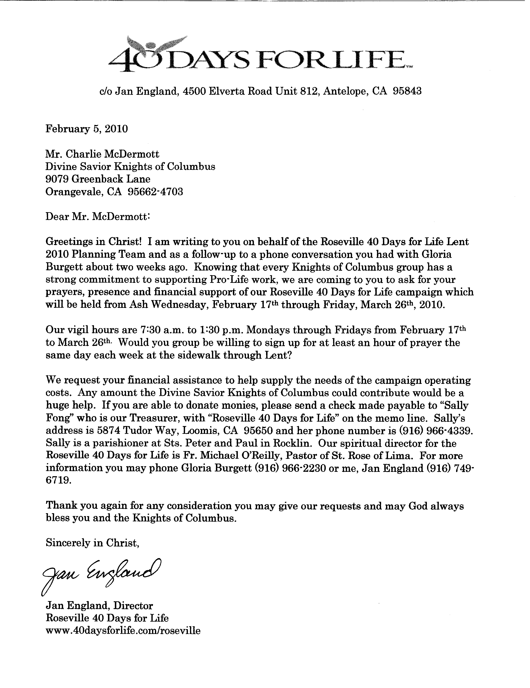

Committee Report – Pro-Life
(As presented by Dave Brodie for Mike Schafer)


Special Prayer Intentions

Please keep the following people in your prayers:

- Debbie McDermott- wife of Charlie McDermott (Neurological Disorder)
- Margaret Quigley (mother-in-law of Allen Brown) (deceased)
- Linda Aiello- wife of Tony Aiello (surgery)
- Mike Wagner (surgery)
- Julia Rapier- mother of Joe Rapier (memory)
- Earl Varney (pneumonia/out of the hospital)
- Sick: Tony Magdaleno, Paul Hoefling, Barbara Lawson, Paul Pyle, Ladene Carvalho, Ernie Deus, Eldon Hancock, Martin Jennings, Jack Joiner and Beverly Ridge
- Deceased: Bob Brodie, Toodie Jennings and George Mann

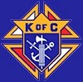

Primary Duties of Council Officers

Grand Knight: The Grand Knight (GK) is the Chief Executive Officer of the Council. He presides over all meetings of the Council and officers, appoints committees, appoints non-elected officers, recommends appointments, secures a Chaplin, appoints committee chairman, countersigns orders drawn for payment of Council funds, countersigns checks, responsible for a Council budget, prepares a Council activity calendar, provides a monthly GK report to the Council newsletter editor, assures that all moneys sent to the treasurer by the financial secretary are deposited, reads or has read any notices pertinent to the Council, represents the Council at state meetings, is chairman of the board of trustees, and is a member pro-tem of all committees and any other duties the Order may impose. For more information, contact Worthy GK Joe Luchi.

Deputy Grand Knight: The Deputy Grand Knight (DGK) is second in command. He assists the GK with Council affairs and fulfills all duties assigned to him by the GK. Should the Grand Knight be absent from a Council meeting, the DGK will preside. He is chairman of the Council’s retention committee and serves as Program Director. For more information, contact Worthy DGK Charlie McDermott.

Chancellor: The Chancellor has a variety of responsibilities. Primarily, he assists the GK and the DGK in the execution of their duties and oversees the Council in both their absences. He is charged with strengthening the members’ interests in Council activities. For more information, contact Worthy Chancellor Guy Sanchez.
Warden: The Warden is the "watchdog" for Council property and degree paraphernalia, except the property of the Financial Secretary, Treasurer and Recorder. He is also responsible for setting up the Council chambers for meetings and ceremonial work, confirms all present at meetings are possessed of the current membership, has charge of and keeps in proper condition all Council property, except for moneys and accounts and record books of the officers. For more information, contact Worthy Warden Don Marnach.
Financial Secretary: The Financial Secretary (FS) is not elected by the Council; but, instead is appointed by the Supreme Knight, upon recommendation of the GK. The term of office is three years. The FS’s main area of responsibilities is maintaining all financial and membership records. The FS collects and receives all moneys from all sources, including annual dues from Council members. He also handles supply orders for the Council officers and members, filing the Report of Officer (#185), and submitting all membership transactions to the Supreme Council. The FS delivers all collected Council funds to the Treasurer at the end of each meeting and keeps Council records, including: number and names of candidates for admission, elected candidates, and initiates. The FS, in coordination with the GK and the Treasurer, prepares the Council budget. For more information, contact Worthy Financial Secretary Mike Wagner.
Treasurer: The Treasurer is responsible for the safekeeping and maintaining of records of all Council funds and accounts. He is responsible for depositing money into the Council’s accounts and provides a certificate of such monies to the GK. He is also responsible for payment of all expenses. He receive all Council funds from the FS, deposits all funds in a bank in a Council account, assists in preparation of the Council budget, and disburses funds from the Council account only with a properly completed Order on Treasurer and co-signature of the GK. For more information, contact Worthy Treasurer Don Rose.
Recorder: The Recorder is similar to a court reporter or a secretary. He is responsible for maintaining a true record of all actions of the Council and its correspondence. The Recorder keeps an accurate record of the doings of his Council, reads all bills, and conducts all correspondence of the Council. For more information, contact Worthy Recorder Ray Coughlin.
Advocate: The Advocate is the legal representative of the Council and serves as the Council’s attorney at trials and investigations of any interest to the Council. While he does not need to be a member of the legal profession, he should be familiar with the Council by-laws, the Order’s Charter, Constitution and Laws (#30), Methods of Conducting a Council Meeting (#1937), and Robert’s Rules of Order. For more information, contact Worthy Advocate Dave Brodie.
Trustees: The Board of Trustees consists of three members elected by the Council and the GK, who serves as chairman of the board. They oversee the work of the Financial Secretary and Treasurer, and with the DGK serve on the Council’s retention committee. During Council elections, only the three-year trustee is voted on, with the others moving on to become two and one-year trustees, respectively. For more information, contact Trustee 1st Year and PGK Dan Freeman, Trustee 2nd Year and PGK Bill Windle, or Trustee 3rd Year and PGK Mike Duskus.
Inside and Outside Guard: The Guards have similar responsibilities, but distinct differences. The Outside Guard tends to the outer door admitting visitors and members to the inner door. Once at the inner door, the Inside Guard checks to make sure membership cards are current. For more information, contact Worthy Inside Guard Bob Reilly or Worthy Outside Guard Steve Mann.
Lecturer: The Lecturer is appointed by the GK to provide both educational and entertaining programs to the Council. He is responsible for the "Good of the Order" portion of Council meetings. In order to provide members with informative and educational programs, he must be knowledgeable and aware of all Council programming. For more information, contact Worthy Grand Knight Joe Luchi.

March / April Birthday List


Name Birthday
Anthony Makarczk 4-Mar
Robert (Bob) Reilly 5-Mar
Edward Gaucher Sr 7-Mar
John McAlpine 7-Mar
Bill Braucht 8-Mar
Thomas Maurice 8-Mar
Tom Henderson 9-Mar
David (Dave) Brodie 16-Mar
Kelvin Joiner 17-Mar
Ronald Jespersen 18-Mar
Raymond Coughlin 24-Mar
Richmond Dean 24-Mar
Thomas Lawson 26-Mar
Daniel (Dan) Tofolla 30-Mar
John Fontana 6-Apr
Michael McCormack 9-Apr
Brian Pertl 22-Apr
We would like to wish each of the members listed a Happy Birthday!!!
John Ridge 23-Apr
Alvin Baughman 25-Apr
Robert Cunha 25-Apr
Dennis Harrington 25-Apr
Charles (Charlie) McDermott 30-Apr

Our Upcoming Events

Date Event Day(s) Location Charity Focus

March
2-Mar Business Meeting Tuesday Parish Hall
21-Mar Pancake Breakfast Sunday Parish Hall Columbian Retirement Home
25-Mar Officers Meeting Thursday
28-Mar Corporate Communion Sunday Main Church

April
6-Apr Business Meeting Tuesday Parish Hall
16-Apr Council Social Friday Parish Hall
24-Apr Recycle Day Saturday Saturday Church St. Vincent DePaul
Parking Lot
29-Apr Officers Meeting Thursday

May
4-May Business Meeting Thursday Parish Hall
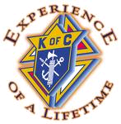
8-May Mother Day Roses Saturday & Vestibule
Sunday
16-May Blood Drive Sunday Parish Hall
16-May Pancake Breakfast Sunday Parish Hall
21-May Golf Tournament Friday
27-May Officers Meeting Thursday Parish Hall

June
1-June Business Meeting Tuesday Parish Hall
5-June Membership Weekend Saturday & Vestibule
Sunday
24-June Officers Meeting Thursday Parish Hall

